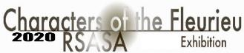
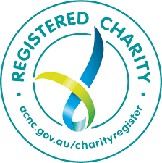
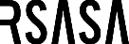

5th Biennial Royal South Australian Society of Arts

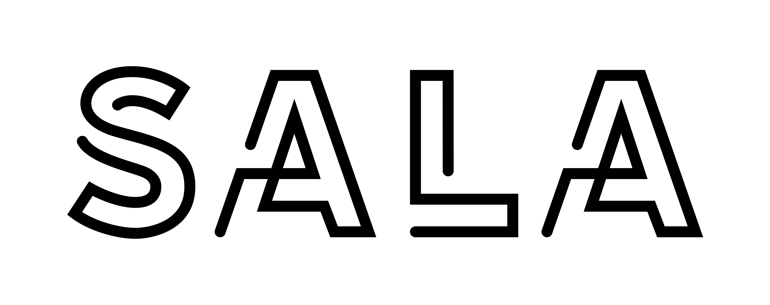

RSASA / SALA CHARACTERS OF THE FLEURIEU ART PRIZE
Exhibition dates - 23th July to 6th Sept
CONDITIONS OF ENTRY
Important Dates:
- Entries closing 4pm ACST Thur 28th May 2020, 4pm Australian CST
- Finalists notified – 25th June
- Finalists deliver to Signal Point – Tues 21st July 10 – 4pm
- Finalists deliver to Pack & Send – Fri 17th July
- Opening – Sun 26th July 2 - 4pm
- Finalists pick up work Sept 6th 3-5pm, Mon/Tues 10-4

An aim of the RSASA is to promote artists and visual arts
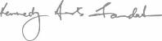
This art prize is held by the RSASA biennially, with through a major acquisition by the Kennedy Arts Foundation

PRIZES
First Prize: $10,000 from the Kennedy Art Foundation Acquisitive Prize
Second Prize: $2,000 from the Royal South Australian Society of Arts
Third Prize: $1,000 from David Baker / President Award
More prizes to be announced later

EXHIBITION VENUE: The 5th biennual RSASA Characters of the Fleurieu Art Prize- 23rd July to 6th Sept 2020 at Signal Point Art Gallery, 5 Laurie Ln, Goolwa SA 5214, Goolwa Wharf Precinct.
TERMS AND CONDITIONS OF ENTRY
- The artist must be living in South Australia at the time of the Exhibition;
- The art work must be –
  - an original work, created and owned by the submitting artist;
  - completed after 28th May 2019 ie within 12 months;
  - in oil, acrylic, watercolour, pastel, mixed media; a drawing, original print, photograph, textile, sculpture;
  - for 2D entries: up to 90cm (incl frame) wide $20 (members) $25 (non-members), 90cm to 150cm wide (incl frame) $30 (members) $35 (non-members) per 2D entry;
  - for 3D entries: $20 (members), $25 (non-members) per 3D sculpture. Maximum weight 20kg;
  - completely dry, suitably presented (eg sides of a stretched canvas painted or one clean colour) and ready to hang or display in a condition which is safe to handle.
- The judges and organisers reserve the right to declare ineligible any work that does not conform to their interpretation of the terms and conditions of entry;
- Maximum two entries per artist;
- All works must be for sale;
- The first prize is acquisitive, and the winning work immediately becomes the property of the Kennedy Arts Foundation;
- The judges have absolute discretion in selecting the Finalists and Winner and judges’ decision will be final and not subject to discussion or appeal and no correspondence will be entered into.

HOW TO ENTER Closing date is 4pm ACST Thur 28th May 2020, 4pm Australian CST.
- Entrants must complete the entry form available by downloading from www.RSASArts.com.au
- Each completed entry form must be submitted to the Royal South Australian Society of Arts (RSASA) before Thursday 28 May 2020, 4pm Australian Central Standard Time together with:
- payment of the non-refundable relevant entry fee
- digital or A4 image of the work
- An entry form will not be considered to be received, until RSASA receives the payment of the entry fee.
- No responsibility is accepted for late, lost or misdirected entries.
- Entry fee is payable with money order, credit card details on entry form OR direct deposit OR cheque OR cash to the RSASA office.
- money order / cheque payable to Royal South Australian Society of Arts
- direct deposit to BSB 015-010 Account 6058-61014
- please include your full name in the bank direct deposit transaction.
- Digital images must be:
- jpg format;
- of a resolution of no less than 300dpi;
- less than 3000x3000 pixels per image;
- not of a file size exceeding five (5) megabytes each;
- name file: artist’s name, title of work, medium, emailed to gallery@RSASArts.com.au
OR
- A4 images must be:
- a high-resolution quality print;
- named in the following way on the back:
artist’s name, title of work, medium
- mailed to Royal South Australian Society of Arts, PO Box 177 Rundle Mall, Adelaide 5000

- DELIVERY OF WORK: Artists will be advised by 25th June
Label on work: labels - artist’s name, title of work, medium and price must be attached to the back of each work. 2D works for hanging MUST have adequate ‘D’ rings. Work without ‘D’ rings will be rejected.
Finalists can deliver work to Signal Point Art Gallery, 5 Laurie Ln, Goolwa SA 5214. Goolwa Wharf Precinct. Tues 21st of July, 10am - 4pm. Ph: 8536 4263
or
deliver work via Pack and Send 458 Pulteney Street, Adelaide depot by COB Friday 17th July. (Bus lane after 3pm.) Courier delivery and return is at artist’s cost. Please ensure your work is insured.
Pack and Send Adelaide 8232 2544

- COLLECTION OF WORK: Sun Sept 6th 3 – 5pm: artists can collect work from Signal Point Gallery on Mon Sept 7th or Tues Sept 8th 10am – 4pm.

- JUDGING: In order to ensure an exhibition with a high standard of work judging will happen in two stages by a panel of three judges.
The judges reserve the right to reject work if the conditions outlined in this form are not met.
Judges select finalists via .jpg / A4 images and choose prize winners by viewing actual work.

- ANNOUNCEMENT OF PRIZE WINNERS: The First Prize Winner of $10,000 and other prize winners, will be announced publicly at the opening of the 2020 RSASA Characters of the Fleurieu Art Prize exhibition on 6 May, 2pm at the Signal Point Art Gallery, 5 Laurie Ln, Goolwa SA 5214.

Copyright: Copyright in the work remains the property of the artist and such right shall not be sold, licensed, or otherwise dealt with by the RSASA without written permission from the artist. And entries may be photographed for the purpose of promoting the RSASA Characters of the Fleurieu Art Prize.

Royal South Australian Society of Arts
1st Floor, Institute Building, corner North Tce & Kintore Ave Adelaide SA 5000
PO Box 177 Rundle Mall Adelaide SA 5000
08 8232 0450 gallery@RSASArts.com.au www.rsasarts.com.au

5th Biennial SALA Royal South Australian Society of Arts

Entry Form

5^{h} Biennial Royal South Australian Society of Arts
RSASA CHARACTERS OF THE FLEURIEU

ART PRIZE EXHIBITION
Exhibition dates: 23 July – 6 Sept 20 at the:
Signal Point Art Gallery, 5 Laurie Ln, Goolwa SA 5214. Goolwa Wharf Precinct.

PRIZES
First Prize: $10,000 from the Kennedy Art Foundation Acquisitive Prize
Second Prize: $2,000 from the Royal South Australian Society of Arts
Third Prize: $1,000 from David Baker / President’s Award
More prizes to be announced later

ENTRIES CLOSE
Thursday 28th May 2020, 4pm Australian CST
Forward to: RSASA (PO Box 177, Rundle Mall SA 5000)
Or email to Gallery@RSASArts.com.au
(please complete all sections)
Personal Details (Please use clear, BLOCK LETTERS)

Title......... First Name ....................................................................
Last Name......................................................................................
Address..........................................................................................
.......................................................State...........Postcode..............
Tel (home).....................................................................................
Tel (mobile)....................................................................................
Email Address:…………………………………………………………….
RSASA member YES / NO ……………
Artists of selected works will be notified by 25th June 2020
Exhibit details:
Title |  |  |  |  | Medium | Selling Price  (GST incl) | Height  in cms | Width in cms | Entry Fee | Cat  Number
1. |  |  |  |  |  |  |  |  | $
2. |  |  |  |  |  |  |  |  | $
 |  |  |  | Total Fee |  |  |  |  | $
Entry fees:
2D: up to 90cm wide (incl frame) $20 (members) $25 (non-members), 90cm and over (incl frame) $30 (members) $35 (non-members),
3D: $25 (members), $30 (non-members) must be less than 20kg
Payment details for entry fees: Credit card - Visa, Master Card, Eftpos, cheque, money order. credit card details on entry form OR direct deposit OR cheque OR cash to the RSASA office.
Credit Card details: No......................................................... Exp Date:............ CVN.............
Name on credit card……………………………………………………….
cheque payable to Royal SA Society of Arts for $.......... or Direct Debit BSB 015-010 A/c No 6058-61014
GST Requirements
GST on net sales amount is the responsibility of the artist if applicable. Please tick appropriate box.

 I have an ABN and am/am not (please circle) registered for GST. My ABN is ......................................
I am a “declared hobby artist” and GST is not applicable.
Artists declaration. Your entry is not complete until you have ticked all boxes below and signed the declaration.
I declare that each entry was completed within 12 months before the Thursday 28th May 2020.
I have read, fully understand and have complied with the size restrictions for each of my entries.
I understand that my entries may be photographed for the purpose of promoting the RSASA Characters of the Fleurieu Art Prize
I understand that the RSASA will NOT accept any changes to my exhibit details after the closing date for entries.
I have read, fully understand and agree to the terms & conditions of the RSASA Characters of the Fleurieu Art Prize.
I have emailed or attached an A4 photo for selection

SIGNED……………………………………….…… DATE ……………….

Office use only  Delivered  Signed .......................................................  Date .............................................. | Collected  Signed ....................................................  Date .........................................

